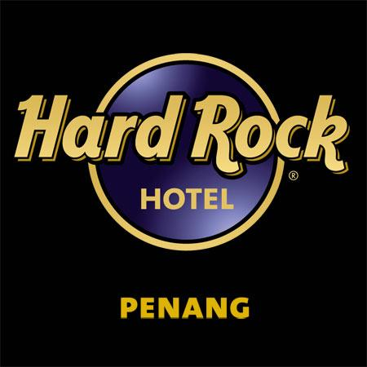
ROCKIN’ PEP AGENTS PACKAGE
WITH HARD ROCK HOTEL PENANG
from € 399
(incl. hotel and MH flights)

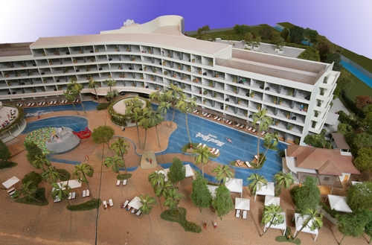
Malaysia Airlines is proud to introduce the Rockin’ PEP Package especially created for travel agents. Book the Rockin’ PEP Package and stay in the first Hard Rock Hotel in Malaysia. Bookings can be made as from 1st of July for travel in October and November 2009. The Hard Rock Hotel Penang will officially open on 19 September 2009 and is situated at the famous ‘Batu Ferringhi Beach’. Go to the website to check out the rockin’ facilities of the Hard Rock Hotel Penang: www.hardrockhotels.net/penang

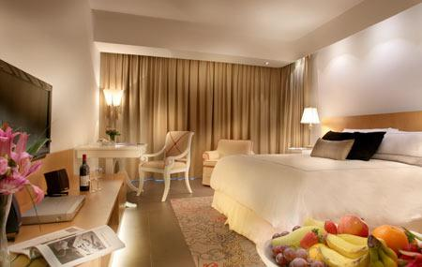
The Rockin’ PEP Package consist of:
- Malaysia Airlines flights AMS/CDG/FRA/STO/ROM-PEN v.v. (incl. taxes & surcharges).
- Five overnight stays including breakfast buffet based on a Hill View double-room.

Please contact the MAS Marketing department for more information about the Rockin’ PEP Package and/or the booking procedure.

